**Narrowcasting - Technical research**

Jenny Kim Doan

Uplifting Onion

13-4-2023

Inhoud

Introduction 3

Research question 3

What kinds of platforms can be used? 4

Which (programming) languages can be fitting for narrowcasting if coding? 6

What proof-of-concepts can be used to demonstrate the functionality of narrowcasting? 6

What technical information is there within Simac, and how to use it to deliver the fullest experience? 8

Conclusion 10

Sources 10

# **Introduction**

This research document entails the technical details behind narrowcasting, and how to utilize it to reach the goal of displaying images and templates to screens. It will include a research question, which will then be gradually answered with sub-questions and lastly a conclusion and sources of information.

## Research question

How to develop a technical narrowcasting system to display templates to screens and stimulate recognition?

Under the research question, there will also be sub questions to split the research into multiple parts and thus to reach an answer:

* What kinds of platforms can be used?
* Which (programming) languages can be fitting for narrowcasting if coding?
* What proof-of-concepts can be used to demonstrate the functionality of narrowcasting?
* What technical information are there within Simac, and how to use it to deliver the fullest experience?

# **What kinds of platforms can be used?**

The best option to display templates for digital signage is Raspberry Pi. Raspberry Pi is a tiny credit card-sized, but powerful computer that can be used for all kinds of needs from a desktop computer to robotics. Due to its compatibility, low electricity usage and price ranging from $15-100, it has become the most favorable platform for digital signages. It also makes no sound due to no moving parts and doesn’t require a fan. As such, it can display templates for months without rebooting or board errors.

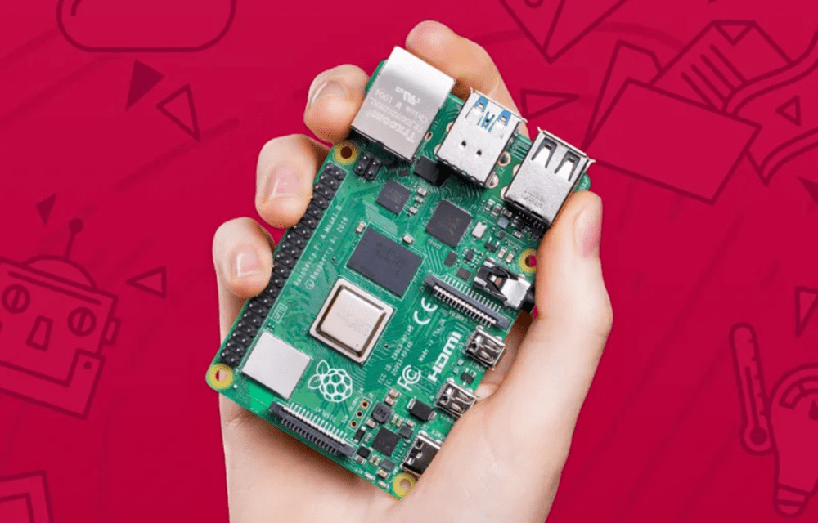

Many kinds of digital signage software have been developed for Raspberry Pi. The most notable examples include:

* PiSignage
* Screenly, also known as Anthias

These platforms offer subscription-based plans and can work offline too.

Aside from Raspberry Pi, it is also possible to get a specialized company to handle everything. The services come into a player made by the company itself and require either a subscription-based plan or buying from a shop for a fixed price. Most notable companies are:

* **SignIPS**, a Dutch based company that offers subscription services with their own media player. It offers a lot of benefits, like free players and a fixed subscription price for each player to make sure companies won’t keep working with outdated technology in the future.
* **Yodeck**, a specialized company that offers a cloud-based digital signage platform that displays templates quickly and easily. It offers a subscription plan and their own Yodeck media player that’s based on Raspberry Pi. They have different tiers, including a free plan for displaying a single screen, ship their own free media player to customers for any plan, and allows an infinite number of monitors to be used for paid plans. Downsides of it is that Yodeck is an US-based company, so it doesn’t use the Euro currency.
* **BrightSign**, a company that delivers media players for a fixed price. It offers multiple models with different needs, with a custom OS that’s specifically made for digital signages. The downside of it is that it requires a lot of setups and needs internet connection for the optimal experience and ease.

# **Which (programming) languages can be fitting for narrowcasting if coding?**

While many players offer a ready-made platform for displaying templates and images, there is also the option to program an own template slide with HTML, CSS, and JavaScript. The upsides to this, is that it can made completely to the companies’ requirements. Custom, exclusive animations can also be added. Downsides to this, however, is that it requires a programmer to develop the system, change the playlist of images when needed, and making sure that they are displayed and animated correctly. This can also cut into the company’s costs.

There are also frameworks for web-development to work with. There are some frameworks, however, that require to purchase a license for general or commercial use. Examples of this are:

* Ext JS ($1,895.00/year for Enterprise tier, $1,295.00/year for Pro)
* Java SE (starts at $15/employee per month)

Luckily most frameworks are free and open source. Example of this is React.js, a JavaScript framework developed by Facebook. It’s benefits to regular JavaScript is that it’s extremely fast and can be worked in Raspberry Pi to develop applications.

Development can be done in Raspberry Pi OS with Visual Studio Code, for which Microsoft rolled official support a few years ago. VS Code is a full-featured IDE that supports full web-development out of the box.

# **What proof-of-concepts can be used to demonstrate the functionality of narrowcasting?**

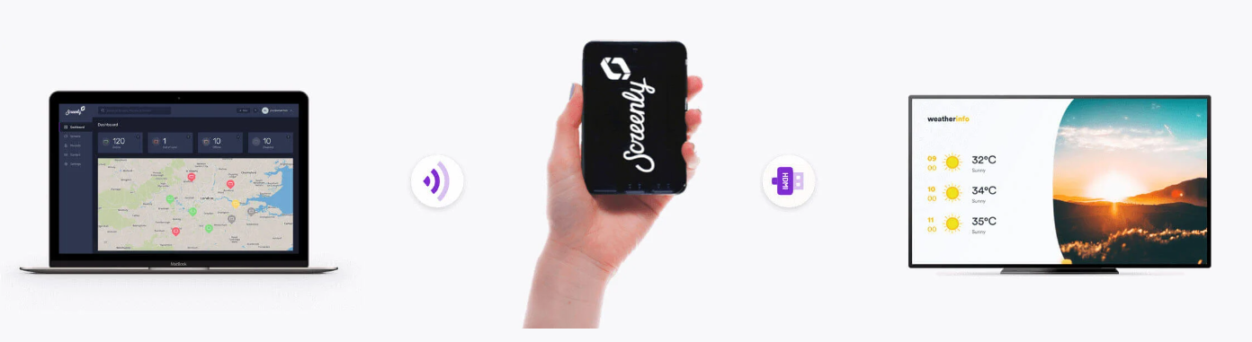

It depends on the platform what kind of steps need to be performed. A lot of the time when using a service, companies would first have to sign up and pay for the subscription fee or apply for the free tier. Afterwards, people must download software to connect to the network of the platform. It will then generate an account with password and an IP-address to access the dashboard to manage the content.

After logging in, users must then input the Wi-Fi settings to connect to the network, configure the screens with HDMI, and register the players. Finally, users can then make playlists to upload and arrange templates to their liking.

Of course, it’s always recommended to read the instructions of the service when using.

When developing an own narrowcasting system, then it just requires casting to a screen with either an HDMI cable or Wi-Fi to use it. It would then require an active PC that’s on for the whole needed duration, or the companies’ own player.

# **What technical information is there within Simac, and how to use it to deliver the fullest experience?**

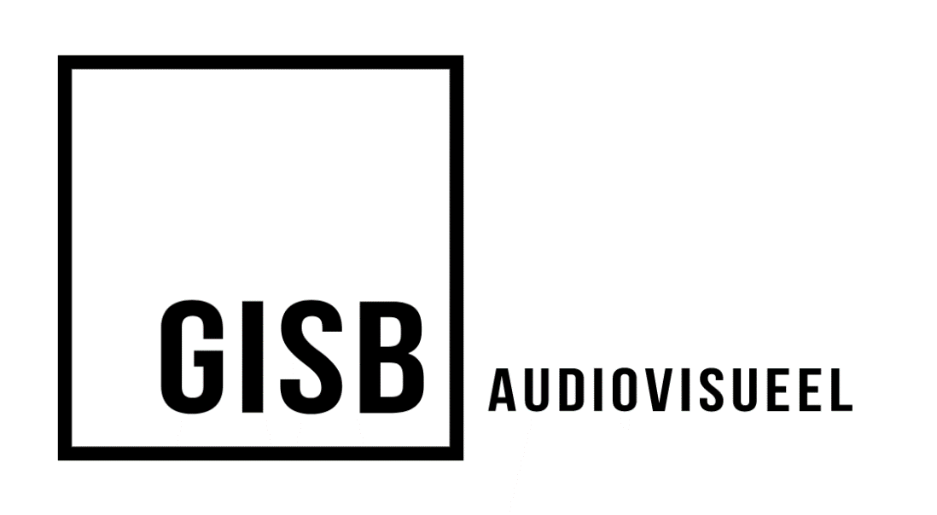

Simac uses the service from GISB Audiovisueel, a Dutch-based company that specializes into audiovisuals for companies. It has worked with many other well-known companies and even government instances including TU/e Eindhoven and Gemeente Landerd. Aside from narrowcasting, they also offer other solutions for livestreaming, video conferences and presentation systems.

GISB has public reviews from companies it has worked with on their site, with most of them being 5-star reviews. The most common positives are:

* Good advice
* Knowledgeable experts
* No conflicts
* Solving problems quick
* Top quality products

According to GISB, their narrowcasting solutions are highly versatile. They use the CMS platform Leftclick, wherein users can input information with predefined templates. Those templates are made with automation in mind, so that companies can update their site, social media, and meetings as usual, and the information is then automatically on the digital signages. This saves a lot of time for manually updating both the website and the digital signages.

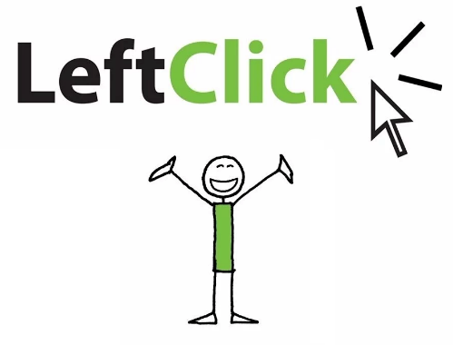

Aside from GISB, LeftClick is also used in many other companies as well including higher education schools, corporations, and municipalities. It is also a Dutch-based company that completely focuses on developing software that's easy to use as clicking the left mouse button, hence the name LeftClick. They have been developing products for narrowcasting since 2004 and are always continuously developing to work towards solutions for clients no matter the size of the project.

Their narrowcasting solution is made to prevent frustration with the focus on user-friendly UI and stable functionality on the software. As such, the system runs on a safe, stable OS and doesn’t require to install any other software or apps. Aside from company news and the weather, they also plenty of other options and templates including:

* The menu
* Room management and status
* Traffic
* Custom layout
* Visitor information
* Company progress
* Offers
* Bar calls and waiting times

The back-end of LeftClick is done with a FMIS-system (**Facilitair Management Informatie Systeem)** from Facilitator. Facilitator is a Dutch software company that specializes in facility management, service management, procurement and building management. Their goal is to help companies with managing their teams, by letting them gain full control of all processes in the organization with software. This results in saving more time, costs, and frustration among employees. Their main product for this is the FMIS-system, which is used by many companies such as Holland Casino, NS and LeftCLick.

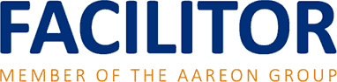

FMIS-system was created to be able to manage multiple levels of a company on tasks, like organizing meetings or receiving visitors. Aside from functionality, it’s also focused on friendly user-experience and security. As such, the systems are customized to the companies’ needs and webbased to require less hassle for both the user and functional manager to use/ manage it. This is implemented in all LeftClick’s product, including narrowcasting.

# **Conclusion**

There are multiple ways to implement a narrowcasting system for a company. The easiest way is to buy a subscription of a company specialized in digital signages and use their players to cast templates, or outright but their players for a retail price if applicable. Users would then have to download software, and then create an account and connect to the provider’s network to manage the templates.

It’s also possible to buy Raspberry Pi’s and then choose a supported platform to cut some costs or develop an own narrowcasting system with HTML, CSS, and JavaScript.

# **Sources**

colloqi. (n.d.). *GitHub - colloqi/piSignage: Digital Signage Player Software for Raspberry Pi, more details at*. Retrieved from GitHub: https://github.com/colloqi/piSignage

*Digital Signage Software Platform for Raspberry Pi |PiSignage*. (n.d.). Retrieved from piSignage: https://pisignage.com/

*Gebruiksvriendelijke narrowcasting software*. (n.d.). Retrieved from LeftClick: https://www.leftclick.cloud/digital_signage

*How to get started with Screenly* (2020). [Motion Picture]. Retrieved from https://www.youtube.com/watch?v=7aNRb8H7z74

*Narrowcasting*. (n.d.). Retrieved from GISB Audiovisueel: https://www.gisb.nl/oplossingen/informatieschermen/narrowcasting/

*Open Source and Easy to use Raspberry Pi Digital Signage System* (2019). [Motion Picture]. Retrieved from https://www.youtube.com/watch?v=4tE-9A1B7AY

*Over ons*. (n.d.). Retrieved from SignIPS: https://signips.com/overons

*OVER ONS*. (n.d.). Retrieved from Facilitator: https://facilitor.nl/over-ons/

*Referenties*. (n.d.). Retrieved from GISB Audiovisueel: https://www.gisb.nl/referenties/

*Screenly - Digital Signage made easy*. (n.d.). Retrieved from Screenly: https://www.screenly.io/

Screenly. (n.d.). *GitHub - Screenly/Anthias: The world&#39;s most popular open source digital signage project.* Retrieved from GitHub: https://github.com/Screenly/Anthias

Stokkelaar, M. (2019, maart). *LEFTCLICK EN FACILITOR, SYSTEMEN DIE ELKAAR AANVULLEN*. Retrieved from Facilitator: https://facilitor.nl/cases/leftclick-en-facilitor-systemen-die-elkaar-aanvullen/

vyshwanara. (2017, mei 11). Retrieved from piSignage: https://blog.pisignage.com/raspberi-pi-digital-signage-player/

*Waarom wij doen wat wij doen?* (n.d.). Retrieved from LeftClick: https://www.leftclick.cloud/nl/about_us